TEACHER’S GUIDE
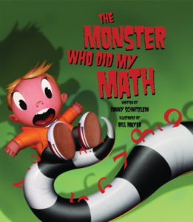
The Monster Who Did My Math
Written by Danny Schnitzlein / Illustrated by Bill Mayer
ISBN: 978-1-56145-668-0
Age Range: 4 – 8
AR Level: 3.1
F&P: GRL O, Gr 3, Genre F
BISAC 1: JUV035000 JUVENILE FICTION / School & Education
BISAC 2: JUV019000 JUVENILE FICTION / Humorous Stories
BISAC 3: JUV052000 JUVENILE FICTION / Monsters

ABOUT THE BOOK
Author, Danny Schnitzlein, developed math anxiety in fifth grade. He sometimes had trouble procrastinating with homework. He decided to write about those two things in The Monster Who Did My Math. In the story, a math-phobic boy has waited until midnight to do his dreaded math homework. A monster appears, offering to do the homework for a fee. After a quick signature on a contract, the boy’s problems are solved, and his homework is ready to turn in the next day. At first, everything adds up perfectly. But when the boy’s math knowledge is tested at school, his troubles begin to multiply. When the monster presents his bill, will our hero have the money―and the math skill―to subtract that wicked monster from his life once and for all?

THEMES
- Facing Fears
- Courage
- Math anxiety
- Responsibility
- Procrastination
- Actions and Consequences

BEFORE YOU READ
- Ask your listeners if there’s a school subject they have trouble with. Ask readers what kinds of things they could do to get a better grasp on their difficult subject. Offer your own advice. Here are some things that might help:
- Ask for help from the teacher before or after school.
- Ask parents for help.
- Make sure your study area is quiet.
- Put aside a certain time each day to study instead of waiting until the last minute.
- Hire a tutor.

AS YOU READ
- Pause occasionally at the end of a scene and ask readers what might happen next.
- Point out the shadows in the illustrations. Why do you think the illustrator chose to “light” the scenes the scenes this way? (Answer: it heightens the scary mood, the danger, and the ominous character of the monster.)

AFTER YOU READ
- Ask listeners to retell the story in their own words.
- Asking someone else to do your homework is a form of cheating. It also means that you won’t learn the material. How does the boy suffer because of cheating?
- Ask your listeners to give definitions of the words “actions,” “consequences,” and “responsibility.” Discuss the relationship between actions and consequences. What are the boy’s actions and consequences each time he asks the monster to do his work? How do you think the boy felt when was cheating? When does the boy take responsibility for his actions? How do you think he felt about himself when he decided to do the work himself?

CLASSROOM ACTIVITIES

HISTORY and TECHNOLOGY
- View the Mathematics Timeline at the website below and choose a famous mathematician. Write a paragraph about their accomplishments. Did he/she make any mistakes? Some famous mathematicians include: Thales, Liu Hui, Zu Chongzhi, Pythagoras, Archimedes, and Euclid. https://mathigon.org/timeline
- The abacus was an important achievement in the history of mathematics. Reasearch the history of the abacus and write a one-page report.
- The pocket calculator is another important step forward for math. Research the invention and write a page on it.
- Alan Turing, a mathemetician, is often called “the father of computer science.” What did Alan Turing invent? How did his invention help the Allies win World War II?
- To learn more about the history of the computer, visit: https://www.livescience.com/20718-computer-history.html

GEOGRAPHY
- Visit this site to learn about the timeline of mathematics. https://mathigon.org/timeline. Choose ten mathematicians from different time periods. On a world map, find the countries where they lived.

VISUAL ARTS
- The Monster Who Did My Math features a homework monster with “pencilly fingers.” In early drafts of the story, he also had a stapler nose and was built out of encyclopedias and dictionaries. Draw a monster for a topic of your choice, made out of things that you’d use in that activity. Some examples: sports, money, music, painting, movies, dancing, television, candy, video games.

VOCABULARY WORD SEARCH
- Find the definitions of the vocabulary words listed for the word search below. Then, complete the word search.
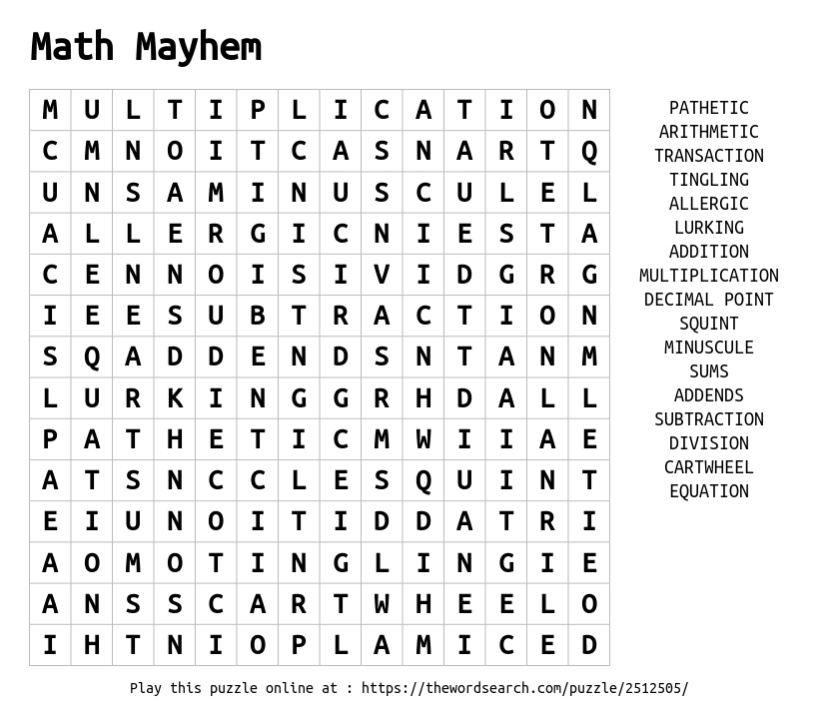

AWARDS

Illustrators 50 Gold Medal (50th Annual Exhibition) ―Society of Illustrators, 2007
Illustration Annual ―Communication Arts, 2008
Kansas State Reading Circle Recommended Reading List (Starred, Primary) ―Kansas National Education Association, 2008
Storytelling World Resource Awards (Honor, Stories for Young Listeners) ―Storytelling World magazine, 2009
25 Books All Young Georgians Should Read ―Georgia Center for the Book, 2010

REVIEWS

“Mayer’s vibrant, computer-generated illustrations, replete with gigantic otherworldly grins and mortal eyes stretched tall with fear, will appeal to fans of afternoon cartoons. Outlandish shadows convey the cautionary nature of the tale, while amusing details keep the mood perpetually fun. Narrated in humorous verse, this ‘tale of mathematical mayhem’ will provide an entertaining addition to math classes and a useful warm-up to tutoring sessions with less-than-enthusiastic students.” ―School Library Journal
“Bill Mayer’s bright, wacky gouache illustrations are every bit as much fun as the story.” ―Courier-Times
“The artwork in this book is masterful and the poetry enjoyable.” ―Science Books & Films
“Danny Schnitzlein’s rhyming story about taking responsibility and doing your homework is great for kids, whether they struggle with math or any other subject.” ―Parent and Teacher US Kids Magazine
“With brilliant, clever rhyming verse, award-winning author Danny Schnitzlein shows what happens when kids become lazy thinkers and attempt to take short cuts with their homework.” ―Janet Boyer
“This would be a good first day activity explaining the importance of problem solving, and doing your own work.” ―Kyle Norman
“This is a hilariously creepy yet adorable story that reminds us that the easy way out isn’t always the easiest way out; sometimes the experience, the journey, the things we learn along the way mean so much more than the end result.” ―Satisfaction for Insatiable Readers
“Not only does the story teach children about the fun that can be had with math, but it also teaches them the importance of choices they make…It’s a story that our family will be reading for years to come, not only because we love the illustrations and math but also because of the principles it teaches.” ―There’s a Book
“Danny Schnitzlein's monster books take Dr. Seuss to the next level by adding sophistication of language and moral choice to the mix, but without losing any of the fun and insanity. You'd be hard pressed to find books that address moral decision-making in such a fun, creative way-- message books without a hint of preachiness.” -- best-childrens-books.com

ABOUT THE AUTHOR
Danny Schnitzlein is an award-winning children’s author who also writes scripts and songs for children’s television. His first book, The Monster Who Ate My Peas, received readers’ choice awards from two states, and has been adapted for children’s theatre, and also as a ballet. The Monster Who Did My Math was named one of the Best Books of 2007 by Atlanta Parent magazine and “A Book All Young Georgians Should Read” by the Georgia Center for the Book. Gnu and Shrew, was voted one of the Best STEM books of 2021 by the National Science Teaching Association. Danny visits schools around the country to share his passion for reading and writing. He lives in Marietta, Georgia with his family and a dog with snuggly super powers.

Besides writing books, Danny is also an artist. “I had an eye-opening experience creating a frame for one of my paintings. I needed to know the outside dimensions of the frame before sawing the wood. Without hesitating, I used Algebra to cross multiply and discover the missing dimensions. This was a huge breakthrough for me. I had used math to create art!”

ABOUT THE ILLUSTRATOR
Bill Mayer is an award-winning graphic artist and the illustrator of a number of picture books, including The Monster Who Did My Math; On My Very First Day of School I Met…; A Walk in the Rain With a Brain; and Brer Rabbit and Boss Lion. He lives in Georgia.

