TEACHER’S GUIDE
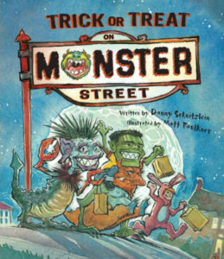

Trick or Treat on Monster Street
Written by Danny Schnitzlein / Illustrated by Matt Faulkner
AR Level: 3.1
F&P: GRL M, Gr 2, Genre F
Themes: Bullying, Facing Fears, Friendship, Prejudice
BISAC 1: JUV000000 JUVENILE FICTION / General
BISAC 2: JUV017030 JUVENILE FICTION / Holidays & Celebrations / Halloween
BISAC 3: JUV019000 JUVENILE FICTION / Humorous Stories
Format: Hardcover
ISBN: 978-1-56145-465-5
Publication Date: 9/1/2008
Page Count: 32
Age Range: 4 – 8

ABOUT THE BOOK
Author, Danny Schnitzlein, has always loved Halloween. “As a kid, I would dress as one monster and visit all the houses in my neighborhood, then dress as a different monster and go around again.” The boy in this story has a fear of monsters. His older brothers tease and bully him, using his fear. When a full moon opens a portal to a world of monsters, the boy goes through it, unknowingly. At first, he’s terrified of this alternate world, but when a group of monster kids befriends him, he realizes that monsters are more like humans than he thought.
The idea for the story sprouted as a “what if”. What if monsters celebrated Halloween backwards from humans. That raised more questions:
Q: Why would monsters wear human masks and costumes on Halloween?
A: Because they’re afraid of humans.
Q: Why would monsters be afraid of humans?
A: Because humans look different from monsters.
Q: What other things might monsters fear?
A: Bunnies, kittens, and puppies.
As the author answered his own questions, the story took shape.
At first glance Trick or Treat on Monster Street may appear to be merely a “Halloween book.” But the story also teaches diversity, acceptance, and inclusivity, and addresses difficult subjects like prejudice, social anxiety, facing fears, and bullying. It can be a good starting point for discussions on all these topics.

THEMES
- Facing Fears
- Prejudice
- Diversity
- Courage
- Bullying
- Social Anxiety
- Friendship

KEY SKILLS
- Communication
- Point of view

BEFORE YOU READ
- Ask for volunteers to share things they’re afraid of. Monsters? The dark? Snakes? Spiders? When did this fear first arise? How do you deal with it?
- Show the book’s cover and ask your listeners what the story might be about.
- The author wrote the story in verse and intended the rhythm to sound like a heartbeat. Ask listeners to see if they can hear the heartbeat.

AS YOU READ
- Pause occasionally to ask how listeners think the boy is feeling. Ask how your listeners think the monsters are feeling.
- At the end of a scene, ask what listeners think might happen next.

AFTER YOU READ
- Ask your listeners to retell the story in their own words.
- Ask your listeners if they ever have trouble going to sleep or being afraid of the dark. Ask if they have any methods for getting rid of their fear. Sometimes knowing that others share your fears can make you feel better.
- Ask listeners if they’re afraid when meeting new people. Talk about ways to deal with social anxiety like deep breathing exercises to help relax.
- Diversity means appreciating people who are different from you. Prejudice means judging others before you know them. Prejudice can lead to discrimination and hurting others. Some things that people use to discriminate: gender, race, social standing, religion, and culture. What does Trick or Treat on Monster Street have to say about prejudice? The boy has an idea about monsters, but after meeting them, he changes his mind. How is prejudice harmful? There’s an old saying, “You can’t judge a book by it’s cover.” How does that apply to this story.

CLASSROOM ACTIVITIES

Social Skills
- As a boy, the book’s author was the target of bullying. In Trick or Treat on Monster Street, the narrator’s brothers are bullies. They take his belongings. They make fun of his costume. They scare him to be cruel. Have you ever had trouble with a bully? How did you deal with him/her? A good mantra for dealing with bullies is, “Talk, walk, tell an adult.”
- Talk: Tell the bully you don’t like what they’re doing. Ask them to stop. Say, “I’m sorry you’re having a bad day today.”
- Walk: If talking doesn’t work, walk away. Find something else to do.
- Tell an adult: If talking and walking don’t work, tell an adult. If you are at home, tell a parent. If you’re at school, tell a teacher. And if you witness someone else being bullied, report it to a parent or teacher.
- Trick or Treat on Monster Street is also a story about friendship and social anxiety. Though the boy is initially afraid of monsters, after making friends in the monster world he gets rid of his fears. Here are a few techniques that can help when making friends. Divide listeners into pairs and have them try out these techniques as they practice meeting a new person.
- Take the first step. Smile. Introduce yourself. Share something about yourself.
- Be open-minded. Don’t judge. Open your heart. Set aside your fears.
- Get to know the person. Ask them about hobbies, favorite books, favorite games, sports, music, etc. What do they do for fun? What are their passions?
- Show warmth, love, and respect.
- Be yourself. Don’t act differently than you usually do.
- Remind yourself that the stranger doesn’t know you’re nervous or afraid. They’re probably also worried about making a good impression and focused on themselves, so they’re not judging you.

Social Studies/Geography
Cultures around the world have celebrations or mythologies related to monsters or death. Research one of these topics and write about it in your own words
- Nyepi Day in Bali, Indonesia. (Each town creates a giant papier mache monster called “ogoh ogoh.”)
- The Day of the Dead celebration in Mexico. (Dia De Los Muertos.) https://dayofthedead.holiday
- Japanese culture features a rich cast of monsters. Their word for monster, yokai, is made up of two kanji that represent “bewitching; calamity” and “apparition; mystery; suspicious.” Research one of these yokai, then describe it in your own words and draw a picture: Kappa, Tanuki, Kitsune, Tengu, Kodama.

History
- Ancient Greek and Roman mythology featured stories about monsters: the hydra, the minotaur, harpies, gorgons, Cyclops. The manticore is a Greek mythological monster with a lion’s body, bat wings, and a human head. Read a children’s version of “Theseus and the Minotaur.” What difficulties does Theseus face in the labyrinth? How does he overcome them? How is he helped by friends?
- Dragons are found in the mythologies of almost every culture all over the world. Read dragon stories from two different countries and compare them. How are they alike? How are they different? http://www.draconika.com/ is a great resource for information about dragons and dragon mythology.
- Ogres originate in French fairy tales and folklore. Find an ogre story and read it. https://mythology.net/monsters/ogre/
- Goblins are found in Anglo-Saxon mythology. Find an example and read it. Here is a good source for goblin stories: https://www.unexplainable.net/info-theories/origins-of-the-goblin.php

Visual Arts
- Create a monster mask (or a human mask) using a paper plate, scissors, feathers, yarn, paints, markers, etc. Display the masks.
- Author, Danny Schnitzlein, often draws monsters with students in his school visits. Draw a monster and give it a name. Many monsters are combinations of human and animal features. For example, the centaur in Greek mythology is half human and half horse. The manticore in Greek mythology was made of a lion’s body, bat wings, and a human head. Try drawing a monster that has animal parts (antlers, antennae, wings, trunk, beak, etc) and human parts (eyes, nose, hair, fingers, toes.) Give your monster clothing, jewelry, a hat, etc. There are no rules for making a monster, so do what you think looks good.
- Try combining parts of two or three animals to draw a monster. Example: a giraffe, a turtle, and a cat. What might that animal be called? (A Turcatraffe?)

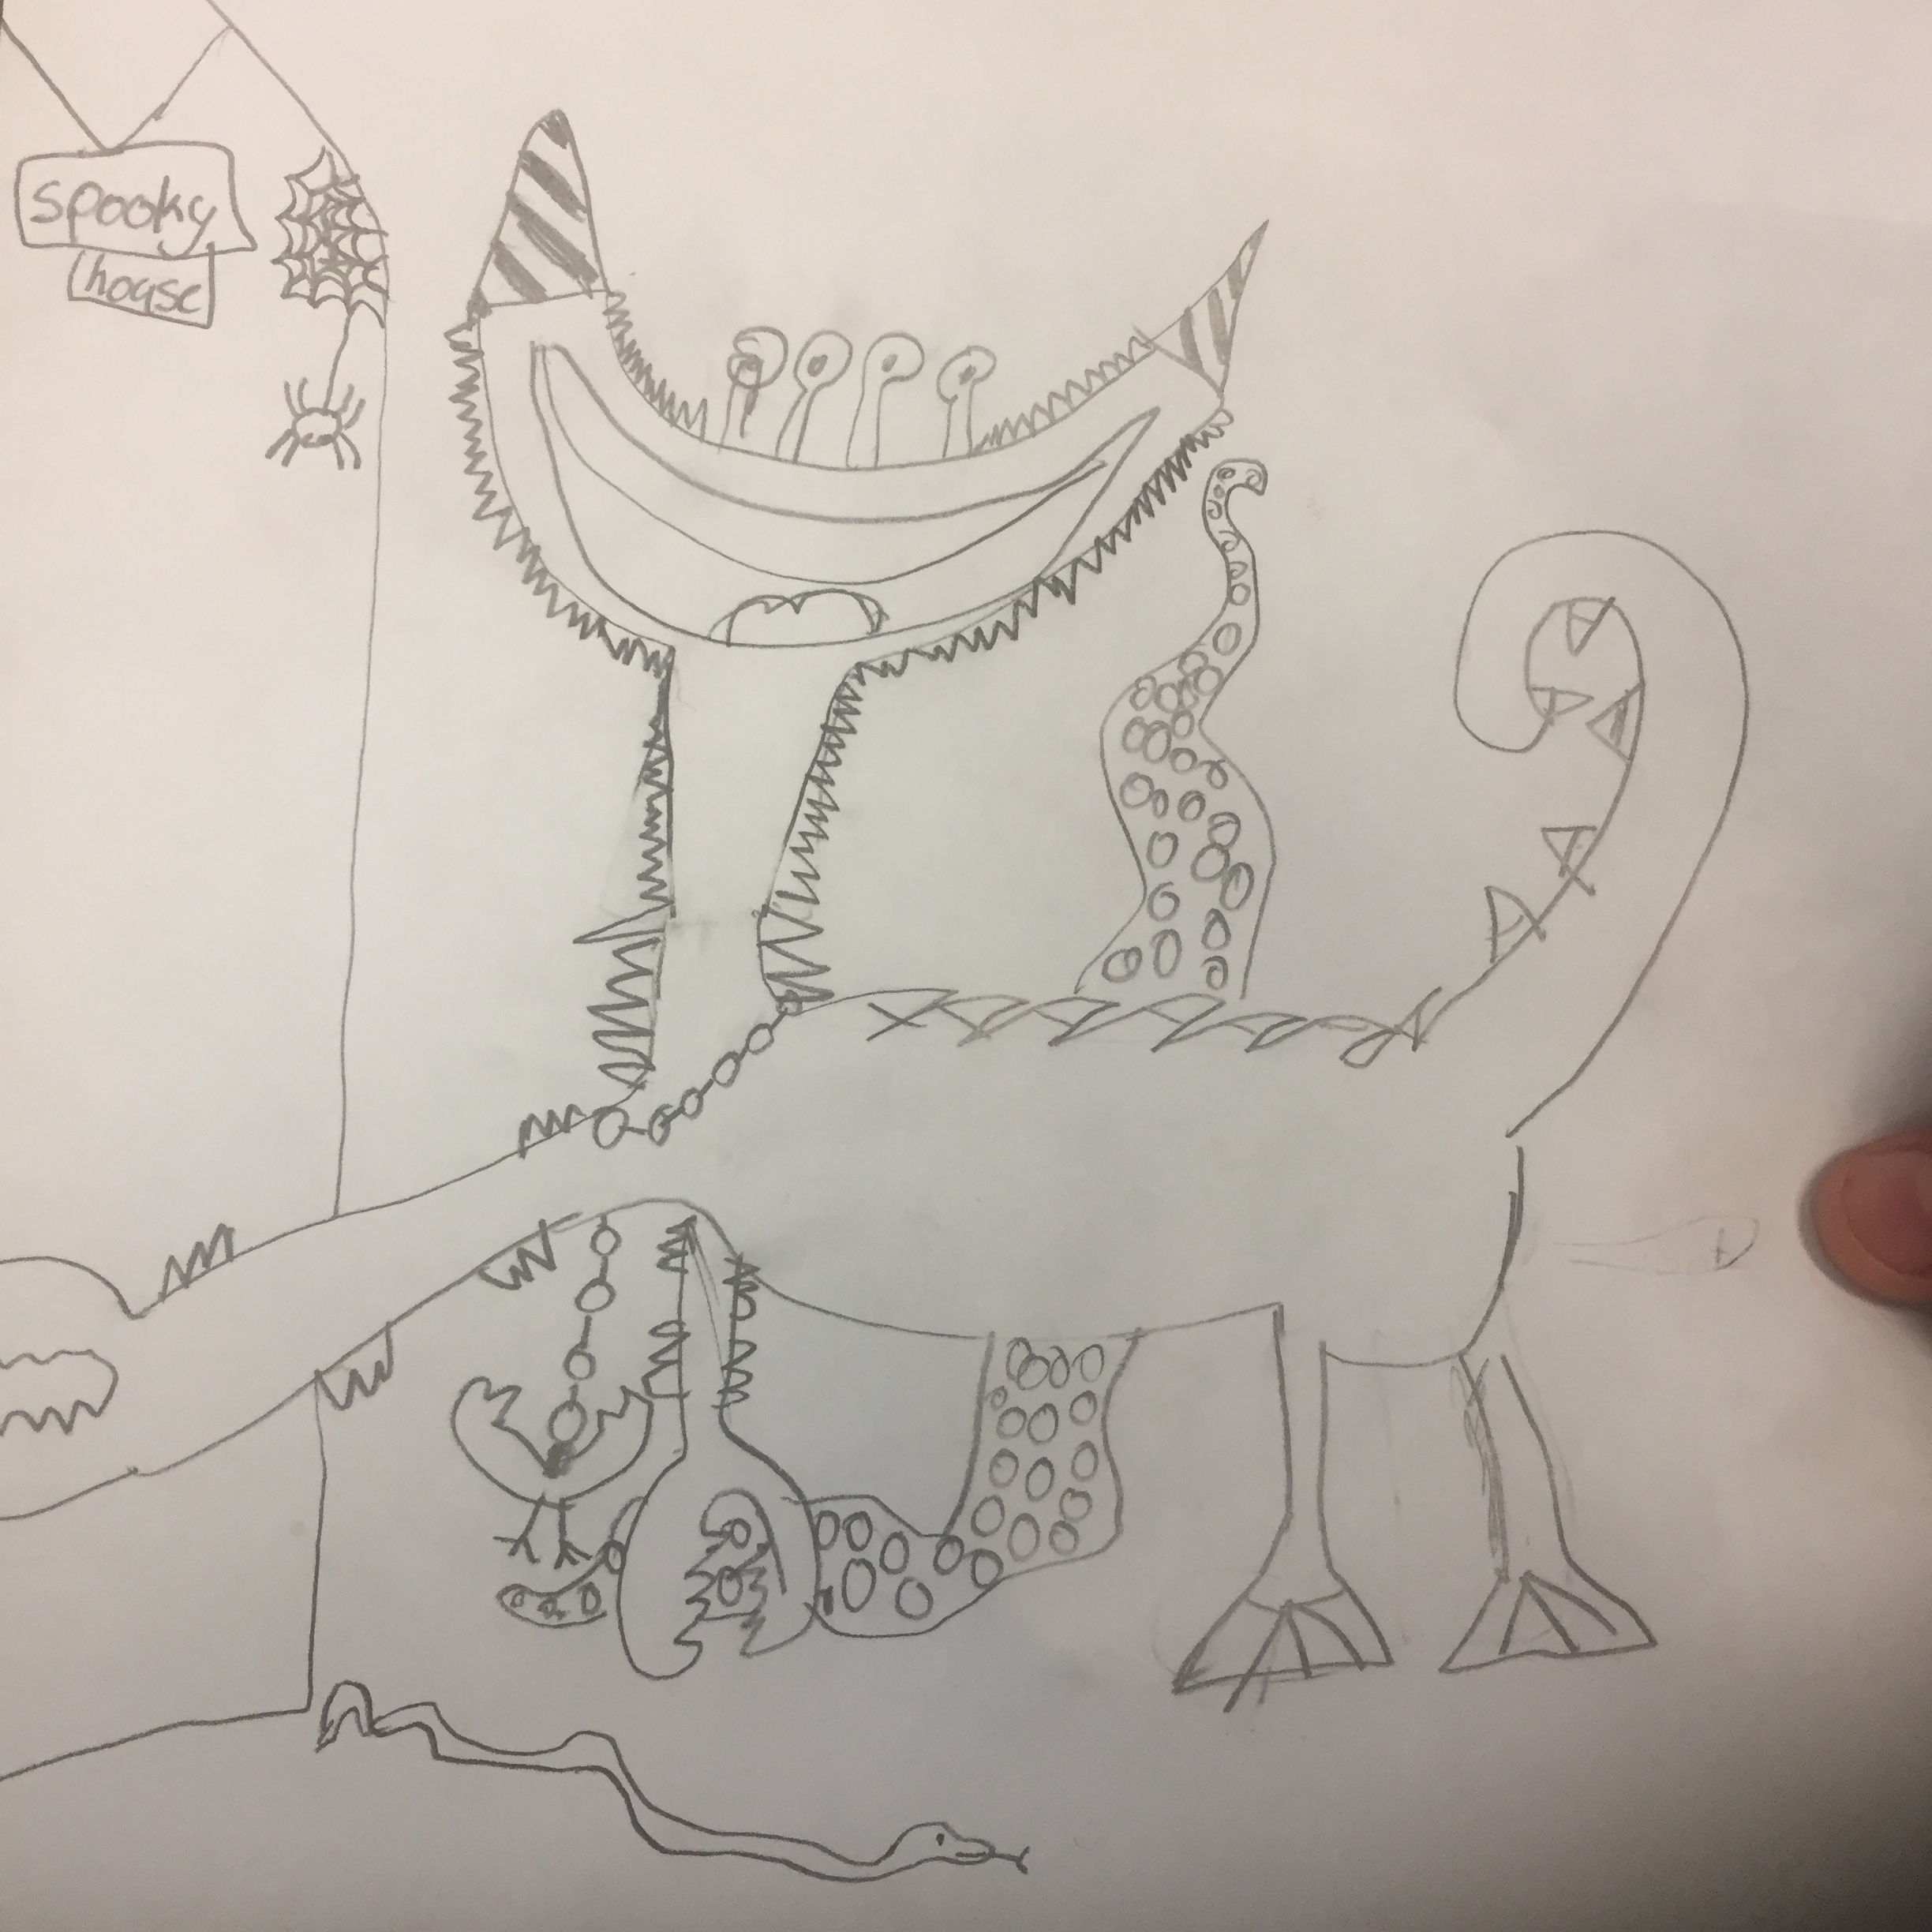

Language Arts
- Write a story about the monster you drew in the Visual Arts activity. What does your monster want most? What’s stopping him/her from getting it? Does your story have a beginning, middle, and end? Does your monster learn anything or change by the story’s end? Is your monster afraid of anything? How could your monster’s fear be used in the story? What does your monster do for fun? Does your monster have any friends? Does your monster have a pet?
- Many famous stories have been written about monsters. Beowulf is one of the oldest stories about a human fighting a monster. A modern author named John Gardner rewrote the Beowulf story from the monster’s point of view. That book is called Grendel. Discuss how stories, and history, can be very different, depending on who tells the story. For information about Beowulf, visit http://www.draconika.com/legends/beowulf.php

VOCABULARY: Use these words from the book in a sentence: gruesome, croon, drumroll, sob, vanish, douse, tattered, beware, squirming.
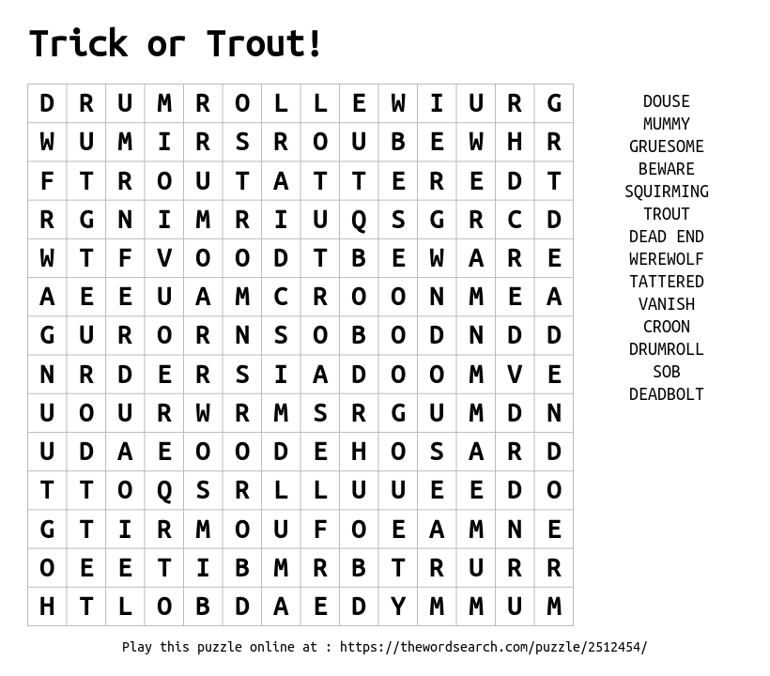

AWARDS FOR TRICK OR TREAT ON MONSTER STREET

Kansas State Reading Circle Recommended Reading List (Primary) ―Kansas National Education Association, 2009

REVIEWS

“Kids will get a kick out of hearing how one little boy overcomes his fears and how his mean brothers get their due in this story told in delightful verse.” ―Baltimore Sun
“A good story with skillful rhymes, exuberant art and lots to look at on every page.” ―San Francisco Chronicle
“Narrated in rhyming verse, Trick or Treat on Monster Street is perfect for children’s library Halloween and holiday collections.” ―Midwest Book Review
“A great Halloween picture book for all your little ghouls and goblins. Your cute little pumpkin will like it too. Highly Recommended.” ―Boys to Books
“This book encourages diversity via not judging by appearances, with a good dose of sibling revenge when the older brothers see what he brings back from trick-or-treating on Monster Street.” ―Janet Boyer
“It details, in a very fun way, that fears can be in the eye of the beholder and are easily overcome.” ―Jenn’s Bookshelves
“A great book for all ages that will keep you in scares and stitches year after year, this is definitely a family friendly read for all your Halloween celebrations.” ―Satisfaction for Insatiable Readers

ABOUT THE AUTHOR
Danny Schnitzlein is an award-winning children’s author who also writes scripts and songs for children’s television. His first book, The Monster Who Ate My Peas, received readers’ choice awards from two states, and has been adapted into a musical and a ballet. The Monster Who Did My Math was named one of the Best Books of 2007 by Atlanta Parent magazine and “A Book All Young Georgians Should Read” by the Georgia Center for the Book. Gnu and Shrew, was voted one of the Best STEM books of 2021 by the National Science Teaching Association. Danny visits schools around the country to share his passion for reading and writing. He lives in Georgia with his family and a dog with mysterious snuggly super powers.

ABOUT THE ILLUSTRATOR
Matt Faulkner is a published author and illustrator of children's books. Some of the published credits of Matt Faulkner include Trick or Treat on Monster Street, Independent Dames: What You Never Knew About the Women and Girls of the American Revolution, and A Taste of Colored Water.

